END OF TERM WRAP-UP
By Adam Hederman
Well it’s that time again. The end of term, and what a term it has been. A lot has happened. So I’m not going to bore you on the intro. Let’s get into this.
It would be a crime not to mention what has been going on sports wise -with our second year basketball team’s excellent performance in the Dublin Plate Final. The match was played in the National Basketball Arena in Tallaght.
The whole team played great. Special thanks to Ms. Peoples along with the excellent coaches Ms. Jackman, Ms. Bors, Ms. Kavanagh and Ms. O’Neill. Not to mention all the u16s and senior players that mentored. One last thanks to Ms. Convery for organising the scoreboard and table officials during the season. Amazing job guys.

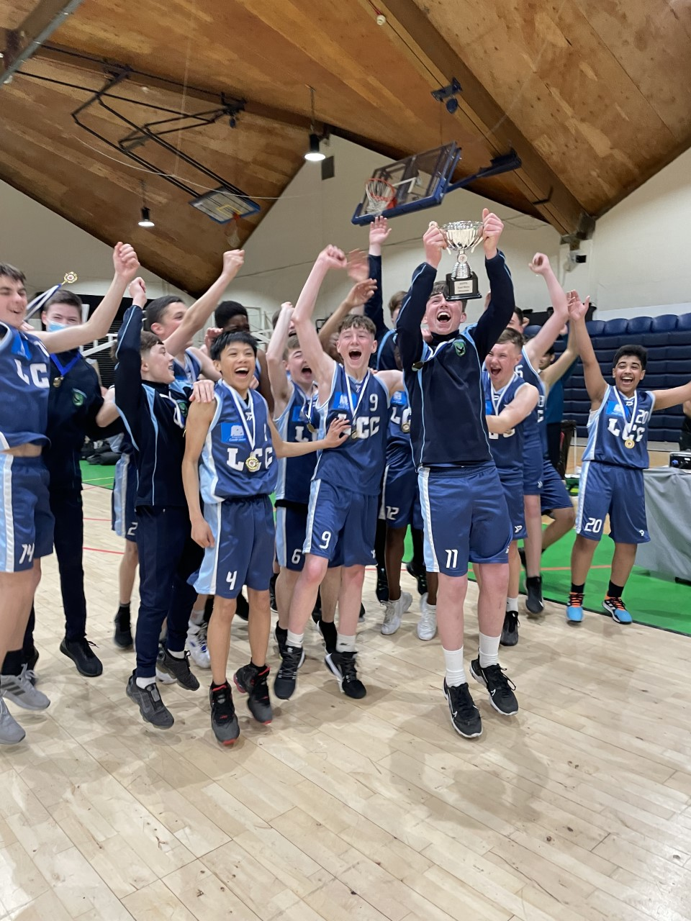
We also need to talk about the Junior Hurling Team. They played in a Junior Hurling Match last week at the Shoreline in Donabate with the results: Lusk CC 4-6, Confey College 1-11. Team Coach Mr. Bolger said “it was a close game for most of the match but the lads showed good resilience and pulled away in the last 10 minutes”.
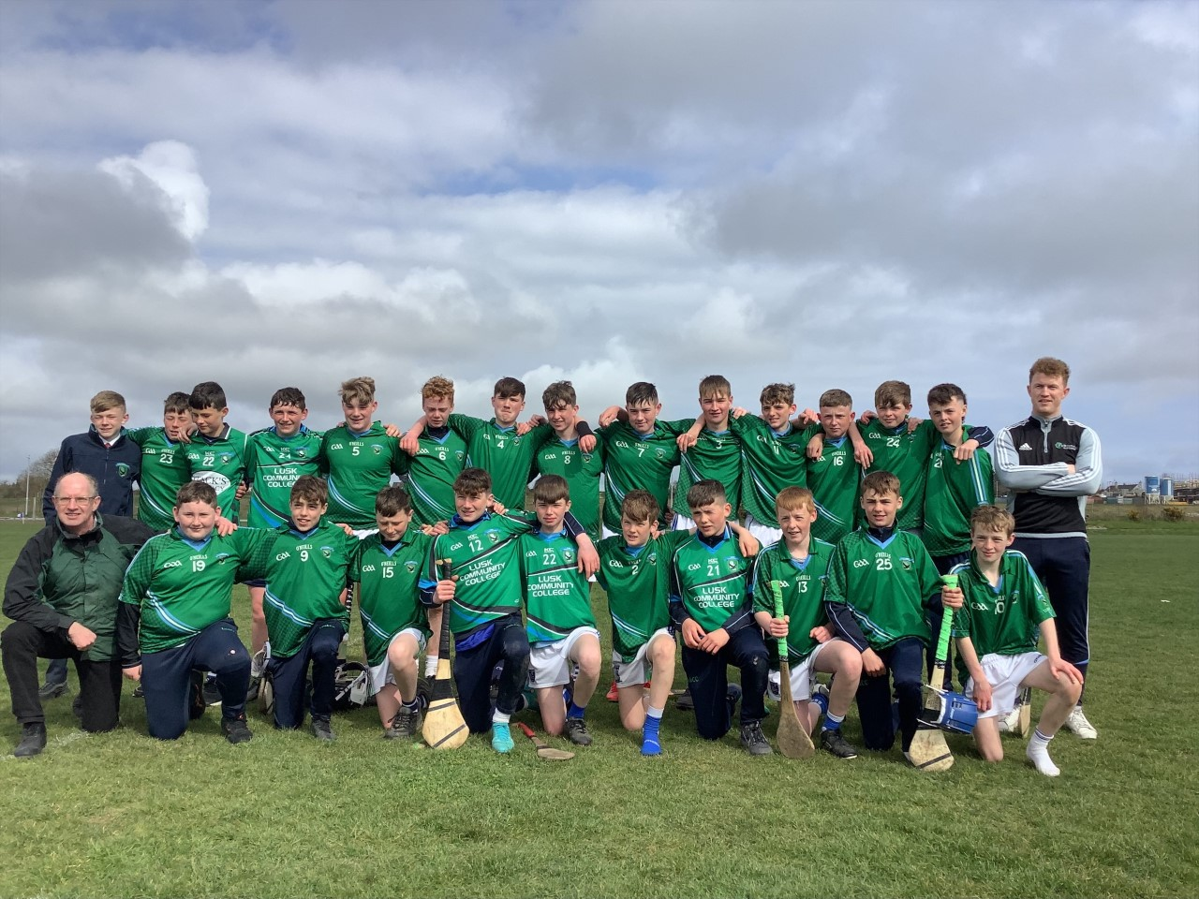

There were some real standout performances on the day also with Harry Cunningham, Dylan Mulligan, Ross O Donoghue, Rory Kerrigan and Tadgh Kendellen putting in stellar efforts.
The team will play Old Bawn Community School in Abbottstown today. We all wish them the best of luck and hope to see them back as the victors.
Sports isn’t the only interesting thing that has happened during the term. The Transition Year students have been rather busy the past week.
They attended the Fighting Words Creative Writing workshop in which they wrote their own short stories that were later published by the Fighting Words charity. Fighting Words is a charity based in Dublin that tries to help encourage all young people to hone and expand their creativity through writing.
They ended the week completing their Adventure Journey as part of their Gaisce Bronze Medal challenge. This included two days of hiking in the Dublin Mountains, covering over 15km each day and taking about 4-5 hours. An amazing feat that was brilliantly done by all.
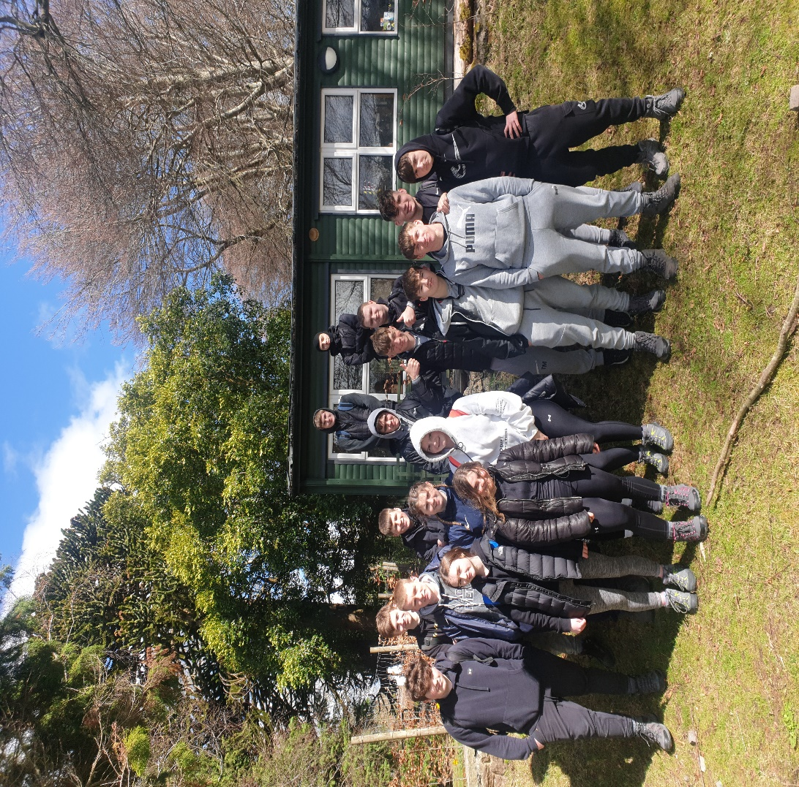
Another thing to mention about writing and creativity-1st Year students were getting creative while spreading awareness for Safer Internet Use earlier in the term. To take part in Safer Internet Use Day, some 1st years entered the Poster Competition to spread Awareness of safe internet use. A big congratulations to Clodagh Dunne in 1 Curie, and also Lucy O’Reilly and Julia Michalik from 1 Picasso who were the winners and received Easter Eggs for their efforts.
There was also the 1st Year Sports Day that the 5th Years and TYs helped out with which took place on Tuesday the 5th of April in the Sports Hub from 9am to 12.15. Their afternoon was spent completing a quiz and Easter Egg hunt. A big well done to Ms. Moran, the TYs and the 5th Years who did a great job organising the day and making sure it was a great success which it was.
This Term has been a very eventful one with lots happening. Now we move on to enjoy the Easter Break. There is one last term to go before the summer. The Press Team would like to thank you for reading so far and hopes everyone has a very Happy Easter.

